Town of Department of

LAKE PARK PUBLIC WORKS

STORM WATER

High Risk Facility Inspection Form

Date of Inspection: 5/2/2019

Name of Business or Owner: CEMEX L.L.C.

Address of Facility: 800 Railroad Ave.

Is the Business name or type different than that listed on the F.D.E.P. permit? No

New Business Name:

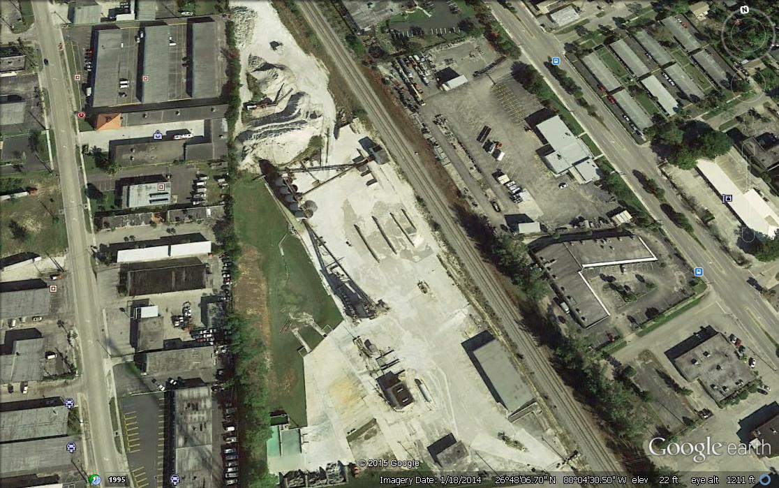 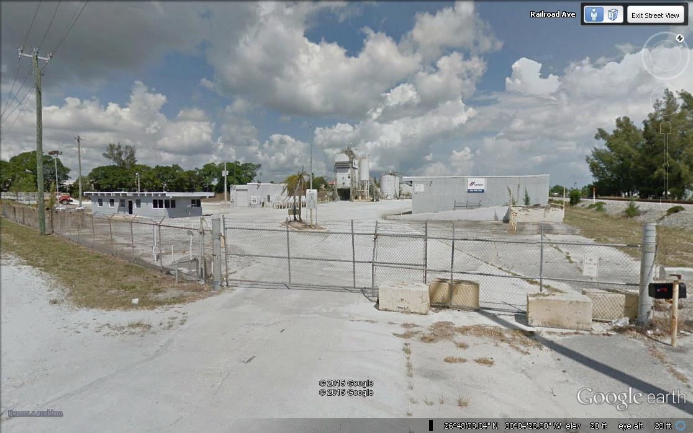

Identification of MS4 component that could receive discharge from this site: Should be contained in on site dry retention pond. If the retention pond overflowed it could discharge to 10th street and Jasmine Dr. Town of Lake Park drainage system and then into the Lake Worth Lagoon

Dose type of business require an MSGP? Yes

Findings:

Evidence of illicit connections to storm sewer ? No

Evidence of dumping / spills to storm sewer ? No

Evidence of wash water going to storm sewer ? No

Storage tanks leaking or improperly contained ? Yes

Stock piles / debris piles uncontained ? Yes

If “yes” to any above , describe: I do not see any containment around storage tanks. I do not see any containment around debris piles.

Type of enforcement action taken: I informed Town of Lake Park Public Works Interim Director Mr. Scherle

Date to verify elimination:

Date of referral to FDEP of facility that may require MSGP: